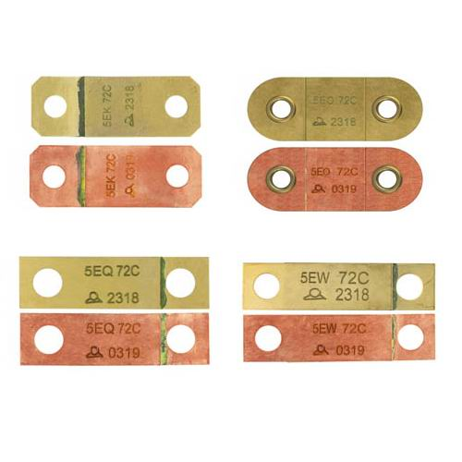

**Type 5EK, 5EO, 5EQ, 5EW**

**Fast triggering eutectic alloy fusible links, in copper or brass**

ROHS compliance: Non- ROHS & ROHS.

Made of thin metal (brass), these fusible links have the shortest response time, between 2 minutes 50 seconds and 3 minutes, for a temperature rise rate of 20°C/min from 25°C, but the fineness of the metal limits their mechanical strength.